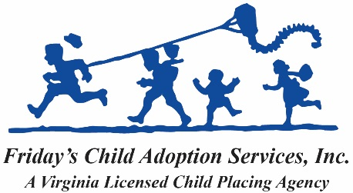
17 W. Pall Mall Street, Winchester, Virginia 22601
adoption@fridayschild.org
http://fridayschild.org
540-532-3272

Please answer the following Safety & Violence questions:
a. Have you ever been arrested, even if the arrest did not result in a
conviction, or convicted, in the United States or abroad?
_________ YES ___________ NO

b. Do you have a history as either a victim or offender of child abuse, physical,
emotional, sexual abuse, or domestic violence, whether in the United States
or abroad?
_________ YES ___________ NO

c. Do you have a history of alcohol, drug or substance abuse, whether in the
United States or abroad?
_________ YES ___________ NO

Please provide an explanation in the space below if “Yes” to any of the above questions.

I understand that I have a duty to disclose new information to Friday’s Child Adoption Services, Inc. if any of the above statements change during the course of the adoption process.
Printed name: __________________________________

Signature: _____________________________________ Date: _____________

